**DAILY ONLINE ACTIVITIES SUMMARY**

|  |  |  |  |  |  |  |  |  |
| --- | --- | --- | --- | --- | --- | --- | --- | --- |
| **Date:** | **26-05-2020** | | | | | **Name:** | **Pavana P** | |
| **Sem & Sec** | **6A** | | | | | **USN:** | **4AL17CS057** | |
| **Online Test Summary** | | | | | | | | |
| **Subject** | | **CGV** | | | | | | |
| **Max. Marks** | | **30** | | **Score** | | | **05** | |
| **Certification Course Summary** | | | | | | | | |
| **Course** | **How to create chatbots** | | | | | | | |
| **Certificate Provider** | | | Cognitive classes | | **Duration** | | | 3 hours |
| **Coding Challenges** | | | | | | | | |
| **Problem Statement:**  1.This is a Python Program to read a number n and print and compute the series “1+2+…+n=”.  2. Python Program to Count the Number of Digits in a Number  3. Python Program to Check if a Number is a Palindrome  4. Python Program to Print all Integers that Aren’t Divisible by Either 2 or 3 and Lie between 1 and 50  5.  Given an array A of size N where the array elements contain values from 1 to N with duplicates, the task is to find total number of subarrays which start and end with the same element  6. Write a program in C to print all permutations of a given string using pointers | | | | | | | | |
| **Status: Completed** | | | | | | | | |
| **Uploaded the report in Github** | | | | | **YES** | | | |
| **If yes Repository name** | | | | | **DAILY STATUS** | | | |
| **Uploaded the report in slack** | | | | | **YES** | | | |

.

**Online Test :**

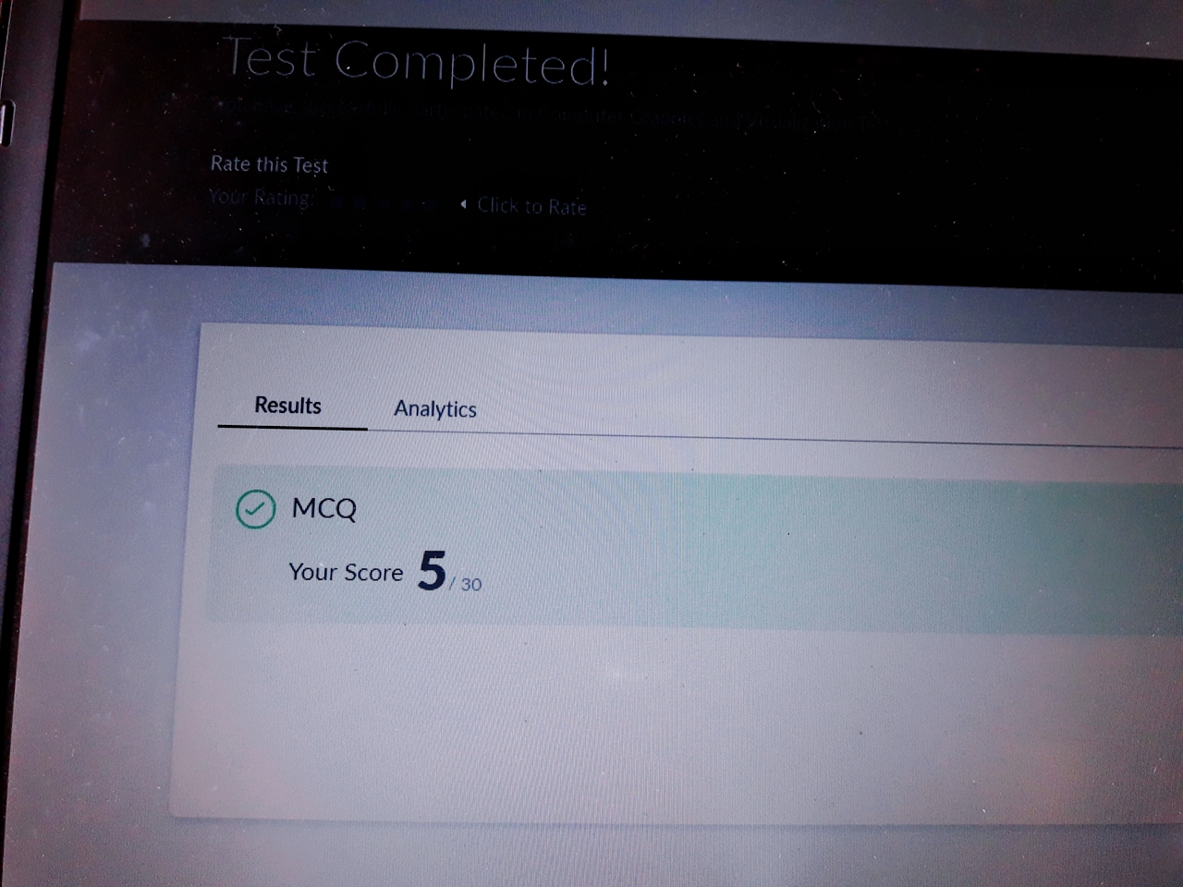Subject:-CGV

**Certification Course Details:**

**How to create chatbots :**

Today I have completed these topics:

1.Introduction to chatbots.

2.Working with intents.

3.Create dialogue skill with intents.

4.Entities .

.

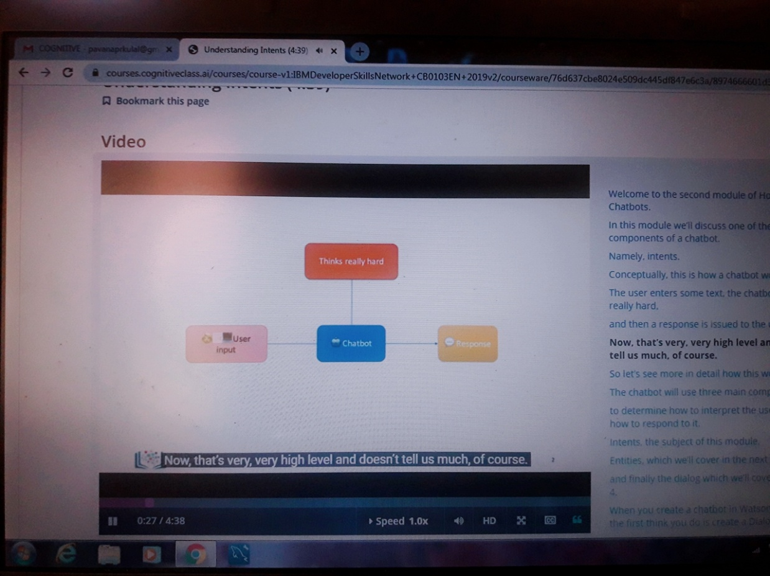

.

**Coding Challenges Details:**

**https://github.com/pavana-p-kulal/DAILY-STATUS/tree/master/26-5-20/Online%20Coding**